# Perform following assignments

# Write your conclusions in comments

# NOTE :

# Every question and bit is explaining a concept, so think and learn!

Function Usage & Programming Assignments:

Q1. What will be output of following

a. type(0)

b. type(0.0)

c. type('A')

d. type(print) -> remember print is function

e. type(3+3j)

f. type(True

NOTE: Similarly check for few other values and clarify the concept

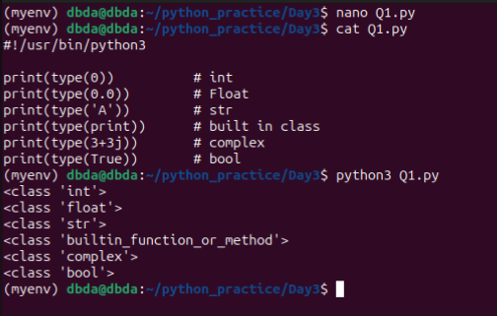

Q2. What will be output of following

a. isinstance(10,int)

b. isinstance(10,float)

c. isinstance(1,bool)

d. isinstance(0,bool)

e. isinstance(78.8,int)

f. isinstance(78.8,float)

g. isinstance(78.8,complex)

h. isinstance(True,bool)

NOTE: Similarly check for few other values and clarify the concept

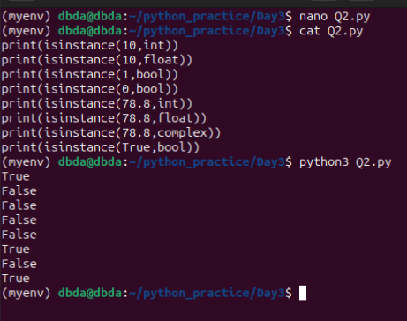

Q3. WAP to take following from user,

roll no : should be int : store in a variable

percentage marks : should be float: store in a variable

Any complex number : should be a complex number : store in a variable

name of student: should be a string : store in a variable

Print values of all four variables

Ans:

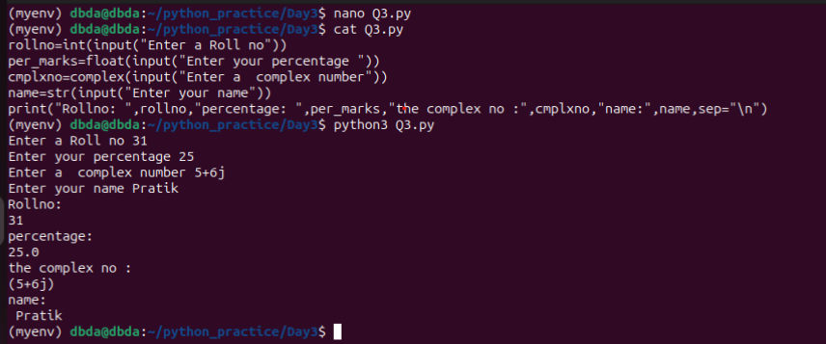

Q4. WAP to convert given integer to binary, hex and octal format

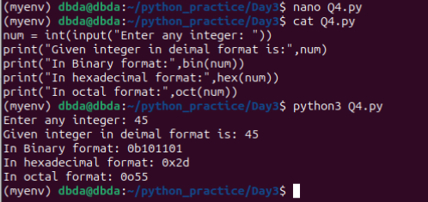

Q5. WAP to convert given binary string to an integer.

NOTE: Binary string should start with '0b' always

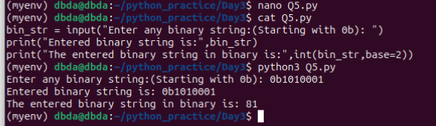

Q6. WAP to convert given octal string to an integer.

NOTE: Binary string should start with '0o' always

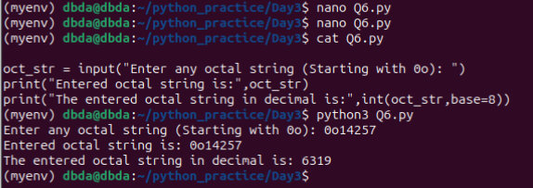

Q7. WAP to convert given hex string to an integer.

NOTE: Binary string should start with '0x' always

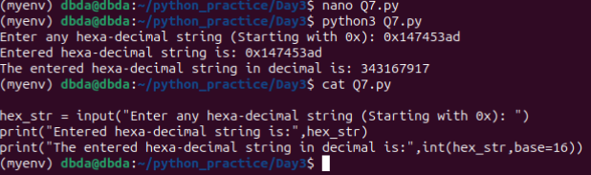

Q8. WAP to take an int from user. Print number of 1's and 0's in binary format of given number.

NOTE: '0b' is suffix in binary string. It should not be included in calculation.

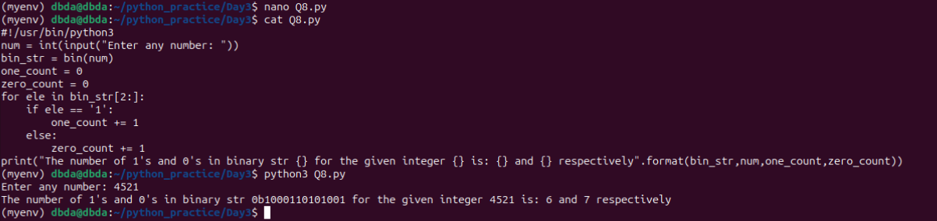.

Q9. Write a menu driven program.

Ask the user which input needs to be converted

1. binary 2. Octal 3. Hex

Then convert given string to integer using int() function

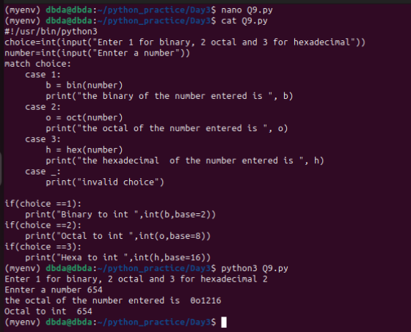

Q10. Manually tell output (Truth value) of following expression, then verify it in python

You can get truth value of an expression by passing it to bool()

Ex. bool(100+56*3) returns True

a. '' (empty string)

b. 10-10

c. 19.99-19.9

d. [] (empty list)

e. range(0)

f. None

g. 0+0.1j

h. -10

i. -9.6

j. 'ABC'+'KL'

k. '-'

l. 'False'

m. False

n. 'None'

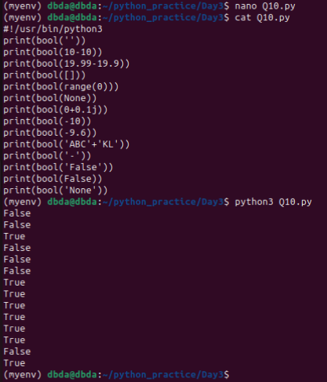

Q11. Find the size of x when x is given following values

Hint : Size of object can be found by sys.getsizeof() function

a. x=0

Check what is size of x

b. x=1

Check what is size of x

c. x=2 ** 20

Check what is size of x

d. x=2 ** 32

Check what is size of x

e. x=2 ** 60

Check what is size of x

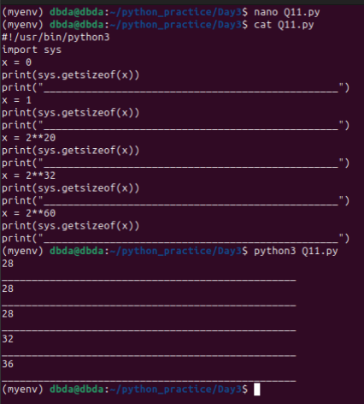

Q12. Find output of following

a. 10 + True

b. int(False)

c. bin(False)

d. hex(True)

e. 1578.67 + False

f. int(5/4)

g. int(9/10)

h. int(-89/10)

i. float(True)

j. float(6*7)

k. float(1e3)

l. float(1e323)

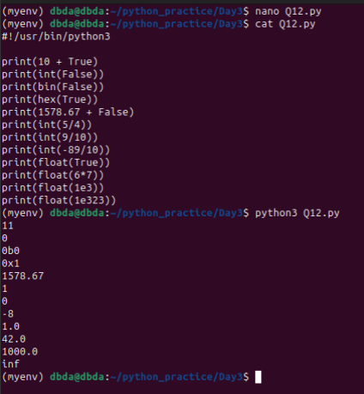

Q13. Solve following

a. Print value of int.bit_length(10)

Print value of bin(10)

Explain output of both functions

b. Take a number from user. Find its square root. And check if square root is an integer or not.

(Hint: Use built-in function from float data type functions for last part)

c. Take hexadecimal string from user and convert it to float

Ex. User input string: '0x1.67e30'

o/p 1.4058074951171875

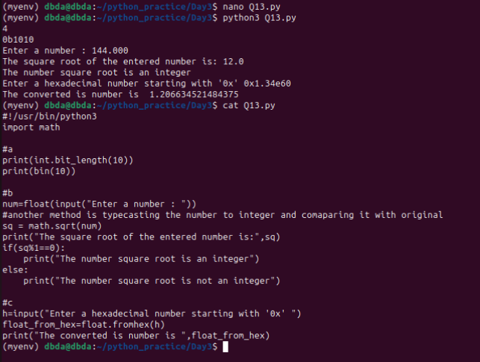

Q14. WAP to convert given floating point number into fraction i..e numerator and denominator, and print them.

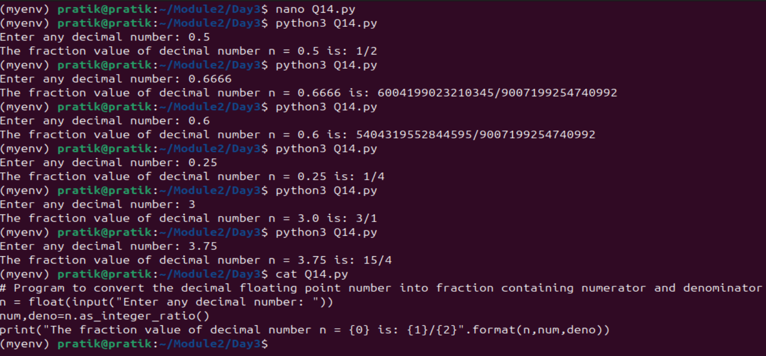

Q15. WAP to create simple calculator in python.

Take two numbers from user and give following options

a. add b. subtract c. divide d. multiply e. integer division f. mod operation

g. check if both numbers are same h. power operation i. square root of both numbers j. log of both numbers

k. gcd (find the the greatest common divisor of the two integers) l. lcm (least common multiple)

(Hint: Use inbuilt functions)

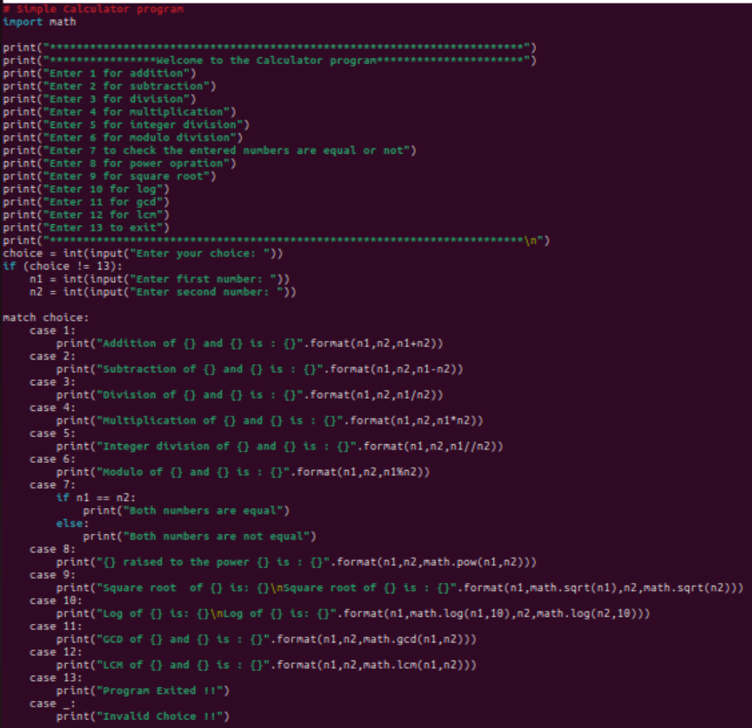

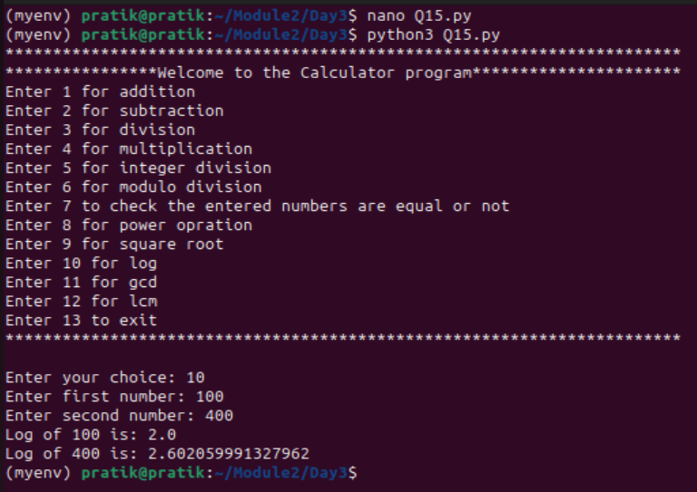

Q16. WAP to check given integer is a perfect square or not.

Don't use built in function

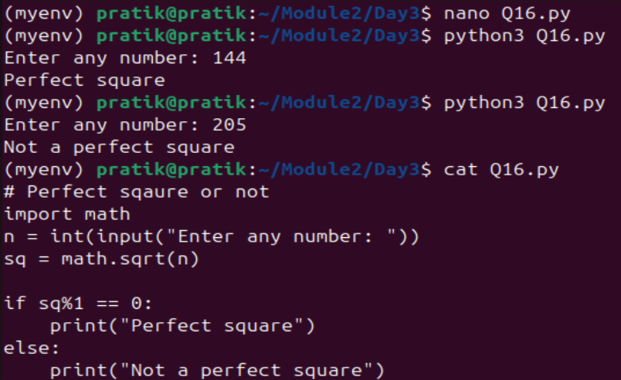

Advanced Assignments:

Q. What is output of following? Explain why such output?

a. bool(hex(0)) -> True because hex() return str which is not empty in this case

b. bool(bin(0)) –> True because bin() return str which is not empty in this case

c. bool(0) -> False because bool(0) is False

d. bool('0') -> Non zero str so True

Q. What is output of following ? Explain

a.

if( 10 == 10.00 ):

print("Equal")

else:

print("not Equal")

Ans: Equal

b.

x=10

y=10.00

if( x == y ):

print("Equal")

else:

print("not Equal")

Ans: Equal

c.

x=10

y=10.00

if( x is y ):

print("Same")

else:

print("Not Same")

Ans: Not same

d.

x=10

y=10

if( x is y ):

print("Same")

else:

print("Not Same")

Ans: Same

Q. What is output of following

a. x = 23+4j

print(x)

Ans: (23+4j)

b. x = 23+4i

Ans: Error

c. x = 23+4k

Ans: Error

d. x=complex('23 + 4j')

Ans: Error because there is spaces between “23 + 4j” string

e. x=complex('23+4j')

print(x)

Ans: {23+4j}

NOTE: Read documentation & Explain why different outputs are coming

https://docs.python.org/3/library/functions.html#complex

Q. Read about difference between byte order types Big-Endian and Little-Endian

https://en.wikipedia.org/wiki/Endianness